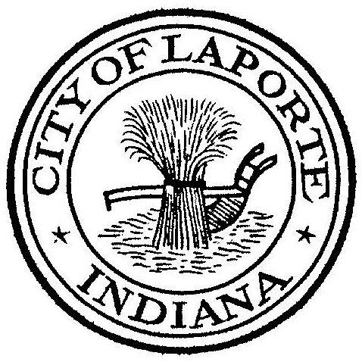
Board of Public Works and Safety
Jessica Romine, Member Tom Dermody, Mayor Mark Kosior, Member
City Hall 801 Michigan Ave., La Porte, IN 46350
Tuesday, October 22, 2024
9:00 AM
AGENDA
Live and archived transmissions are available at
https://www.facebook.com/cityoflaportein and https://www.youtube.com/cityoflaportein.
- Call To Order
- Pledge Of Allegiance
- Approval Of Minutes
- Public Comment: In Person and via Facebook Live
- Clerk-Treasurer: Claims Approval
-Approval of Physical Inventory Proposal: CBIZ
- Department Head Reports
- New Business:
-Nick Otis: Spectrum Court Order
Spectrum Appraisals (3) Approval
-Andy Snyder: Request Approval of Magnagrip HGAC Quote
-Roscoe Hoffman: Ivy Tech Internship
-Craig Phillips/Nick Minich: Hunters Woods Phase 1 Final Plat Approval
-Tim Werner: Proposal for Engineering Services-SR39 Elevated Tank Design
-Mike Fraze: Approval for Safety Bollards
- Unfinished Business:
- Other Business: Next regularly scheduled meeting: Wednesday, November, 6 2024 at 9a
Election Day, Tuesday, November 5th
- Adjourn

